UMGC CMSC 495

WEEKLY Project Status Report

|  |
| --- |
| Project Name: Team 3 USACE Work Request Application |
| Date: 20211207 (Week 7) |
| Project Manager: Dave Leake |

# 1.0 Milestones and Schedule Dates

|  |  |  |
| --- | --- | --- |
| **Milestones** | **Estimated Completion Date** | **Percent**  **Complete** |
| User Guide | 20211106 | 100 |
| Test Plan | 20211108 | 100 |
| User Experience | 20211109 | 100 |
| Design | 20211116 | 100 |
| Source drop 1 Hello World | 20211123 | 100 |
| Source drop 2 DB Insert/Select/Update/Delete Access | 20211130 | 100 |
| Source Drop 3 UI Model | 20211207 | 100 |
| Azure Win2019/SQL2019 for rapid DB Development | 20211204 | 100 |

# 2.0 Accomplishments This Period

## 2.1 Activities

Refined User Guide with actual UI Screenshots

Created / verified DB Access: LocalHost & Azure

Called Azure and Localhost DB from App

Created Phase_3.jar

20211205 Team Sycn

## 2.2 Activities Planned But Not Achieved

N/A

## 2.3 Deliverables Completed

DB Access verified

## 2.4 Deliverables Planned But Not Completed

N/A

# 3.0 Accomplishments Planned for Next Period

ISUD: WRProjectInfo, WRWorkRequest

Finalize UI and Application for scope of project

## 3.1 Activities

20211211: Team Sync. Minimum 4 hours.

20211212: Team Sync. Minimum 4 hours.

## 3.2 Deliverables

Earned Value Analysis

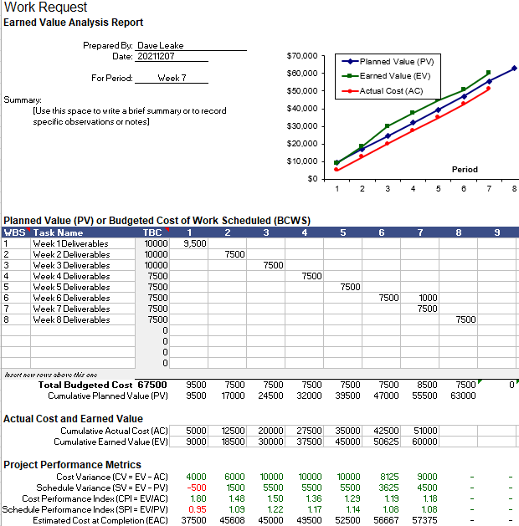

# 4.0 To Date Earned Values

|  |  |  |  |  |  |  |  |  |
| --- | --- | --- | --- | --- | --- | --- | --- | --- |
|  | PV | AC | EV | CV | SV | CPI | SPI | EAC |
| Current | 55500 | 5100 | 60000 | 9000 | 4500 | 1.18 | 1.08 | 57375 |

|  |  |  |
| --- | --- | --- |
| * Earned Value Indicators: | | |
| * PV = Planned Value or Budgeted Cost of Work Scheduled * AC = Actual Cost of Work Performed * EV = Earned Value or Budgeted Cost of Work Performed, | * CV = Cost Variance * SV = Schedule Variance * CPI = Cost Performance Index | * SPI = Schedule Performance Index * EAC = Estimate at Completion |

UMGC CMSC 495

# 5.0 Risks and Issues Summary

## 5.1 New

[List the new major risks or issues that will be addressed in the next period.]

|  |  |  |  |
| --- | --- | --- | --- |
| Risk/Issue # | Description | Action | Owner |
| Coupling to SharePoint | Analysis shows the original DB is tightly coupled to SharePoint which eliminates some functionality to be able to be ported over | Continue development and analysis | Dave |
|  |  |  |  |
|  |  |  |  |

## 5.2 History

[List the previous major risks and issues for the project. The Project Risk Log, AMC-PMO-307, and the Project Issue Log, AMC-PMO-310, may be attached for further support.]

|  |  |  |  |
| --- | --- | --- | --- |
| Risk/Issue # | Description | Status  (Open/Closed) | Owner |
| Employee Skills | Need to gauge current team member skill sets, leverage where appropriate | closed | Dave |
| Changes to IDE | Chosen products licensing may impede this project and force another route | closed | IAN |
|  |  |  |  |

# Change Request Summary

[List the changes requested that might impact scope, schedule, and cost.]

|  |  |  |  |
| --- | --- | --- | --- |
| Change ID # | Description | Change Request Type  (Defect Repair, Enhancement, Addition, etc.) | Status |
| Login | Updated Logine to accept Azure Option | Enhancement | Complete |
| OverTime Request | Need to approve overtime to participating team members to keep project on schedule | Personnel Shortage | Not Needed |
| Azure | Azure Server Stood Up for consideration | Enhancement for ease of access | Complete |